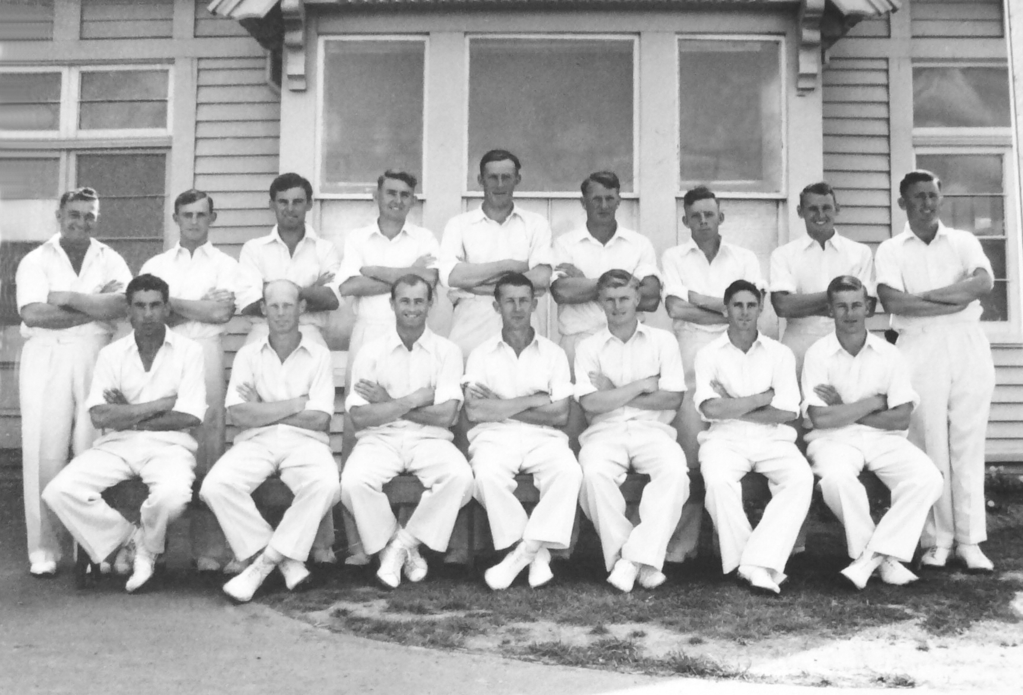

**Canterbury Representative Team 1956/57**

**Back Row:** GN Gearry, IM Sinclair, BMJ Dineen, DJ Reid, AR MacGibbon, KJ McNichol, JW Kiddey, AG Duckmanton, ME Chapple

**Front Row:** SC Guillen MB Poore, PGZ Harris, RT Dowker, JW D’Arcy, BA Haworth, DL Gallop